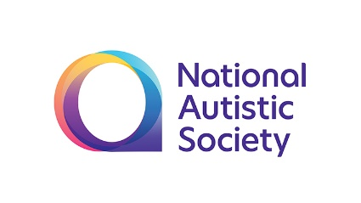
Recruitment pack
Board Trustee
February 2020

Dear Applicant,
Role of Board Trustee
Thank you for your interest in this role. In this pack, you’ll find information that will tell you more about our organisation and the role of a board trustee. Please note that on this occasion we are seeking to recruit two people to join the board of trustees:
- Someone who has the experience and qualifications to chair the board’s plans and resources committee. It is probable that this individual will be a current or former Finance Director at a comparable organisation;
- A person with experience in the leadership and governance of schools who can therefore chair one of our school’s local governing bodies and sit on the board’s education quality and development committee.
To apply, please send a CV and covering letter to bruce.thompson@nas.org.uk. Your letter should indicate why you are interested in the role, and why you believe you have the skills and experience to meet the person specification. Details for two referees are also requested.
Dates for interviews will be advised to short listed applicants in due course.
You will also have received or downloaded an equal opportunities monitoring form. We ask for this information for equal opportunities monitoring purposes, in line with our commitment to equality and diversity. However, you do not have to complete this form.
The deadline for submission of applications is 15 March and interview dates will be advised to shortlisted candidates. Applications can be submitted by post or email to:
Bruce Thompson
Company Secretary
The National Autistic Society
393-395 City Road,
London,
EC1V 1NG
bruce.thompson@nas.org.uk

If you have any queries or would like to discuss any aspect of trusteeship at the NAS, please email bruce.thompson@nas.org.uk or call on 0207 923 5709. We look forward to hearing from you.
Yours sincerely

Dr Carol Homden CBE Dr 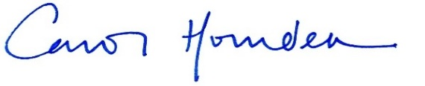

Dr Carol Homden CBE
Chair of Trustees

Contents
About The National Autistic Society 4
What we do 5
Our story 6
Looking Forward 9
Our Structure 10
About the Board 11
Role description 14
Person specification 16
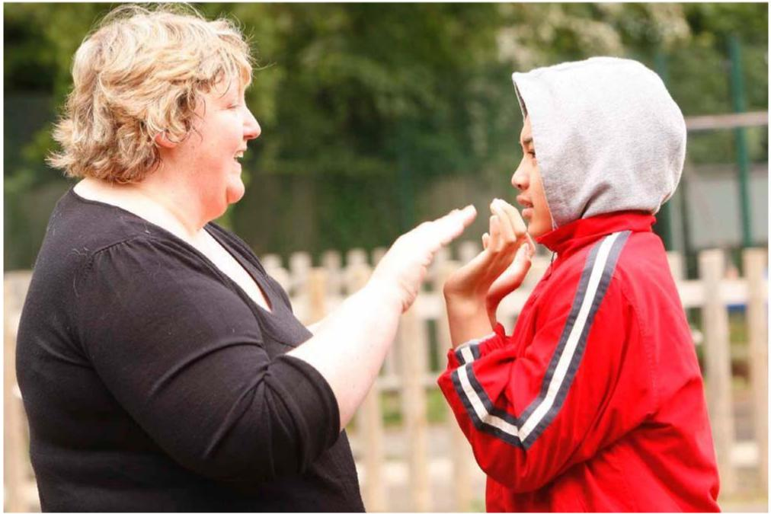

About The National Autistic Society

The National Autistic Society (NAS) is the leading UK charity for people with autism (including Asperger syndrome) and their families. We provide information, support and pioneering services and campaign for a better world for people with autism.
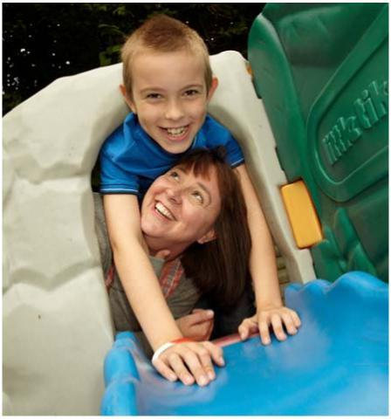
We were formed in 1962 by a group of parents who were passionate about ensuring a better future for their children. Today, we have a head office in London, national offices in Northern Ireland, Scotland and Wales, and a network of regional offices and volunteer-run branches.
Across the UK, we have more than 3,400 staff employed in a wide variety of roles, from teaching staff to family support workers; campaign officers to speech and language therapists; and helpline advisers to administrators.
You’ll find more information about us on our website: www.autism.org.uk.

Our vision, mission and values
All our work is guided by our vision, mission and values, which have been developed alongside autistic people and family members.

Our vision
We want to see a society that works for autistic people.

Our mission
To transform lives by providing support, information and practical advice for the 700,000 autistic adults and children in the UK, as well as their three million family members and carers.

To change attitudes by improving public understanding of autism and helping businesses, local authorities and government to provide more autism-friendly spaces, deliver better services and improve laws.

Our values
- We learn from real experience. We’ve spent over 50 years working together with people on the autism spectrum. No one has more practical knowledge of autism. But we move with the times and we understand that there’s always more to learn.
- We tell it like it is. We share what we have learned about autism, so that more people can make informed decisions and lead the best lives possible.
- We inspire. We celebrate progress, open up new possibilities, spur people into action and motivate change.
- We are courageous. We won’t accept ignorance or inequality, and we’ll never stop pushing for more understanding, greater support and a better world for people on the autism spectrum.

What we do
We have over 23,000 members, more than 115 branches and provide:
- information, advice, advocacy, training and support for individuals and their families
- information and training for health, education and other professionals working with people with autism and their families
- specialist residential, supported living, outreach and day services for adults
- specialist schools and education outreach services for children
- out-of-school services for children and young people
- employment training and support and social programmes for adults with autism.
A local charity with a national presence, we campaign and lobby for lasting positive change for those affected by autism in England, Northern Ireland, Scotland and Wales.
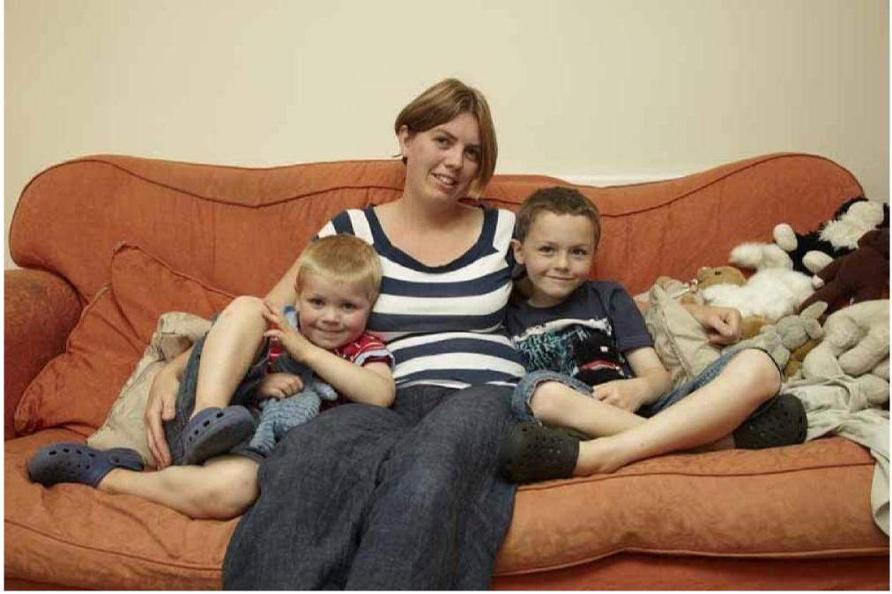

Our story
We started in 1962 as a small group of friends who were frustrated at the lack of understanding and help available for us and our children. Since then, we have grown into the UK’s leading
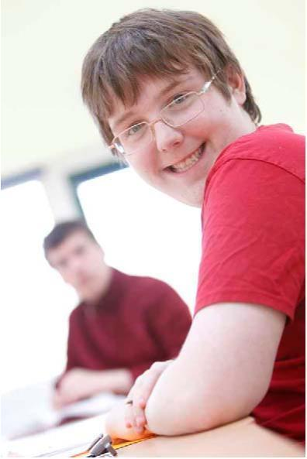
autism charity but our vision remains the same: a world where all people living with autism get to lead the life they choose.
1962. First meeting of founding parents
A group of parents come together to start what will later be called The National Autistic Society.
1963. First NAS logo developed
The first NAS logo is designed by a parent member of the Executive Committee, Gerald Gasson, and uses the symbol of a puzzle piece.
1965. Sybil Elgar School opens
Sybil Elgar is asked by some of the founding parents of the NAS to teach their children. Since it opened, 383 students have attended the NAS Sybil Elgar School in Ealing, London.
1967. First issue of Communication magazine
The first issue of our members’ magazine, Communication, is published.
1968. Helen Allison School opens
Due to the popularity of our first school, Sybil Elgar suggests the NAS opens a second school in Gravesend; it is named after the first General Secretary, Helen Allison, upon her retirement.
1974. Somerset Court opens
The residential community in Brent Knoll, Somerset opens to provide continued support and care for students leaving Sybil Elgar School, and others.
1974. Radlett Lodge School opens
The school is in Radlett in rural Hertfordshire and supports children and young people with autism aged four to 19. Since it opened, 291 students have attended the school.
1976. Robert Ogden School opens
The school, originally situated in Wath upon Dearne, Rotherham and called Storm House, is in Thurnscoe, near Rotherham in South Yorkshire. The school supports children and young people with autism aged seven to 19. Since it opened, 480 students have attended the schools.
1982. Renamed The National Autistic Society
In 1982 the charity changes its name from The National Society for Autistic Children to The National Autistic Society.
1985. Broomhayes School opens
The school, originally in Westward Ho!, Devon, and now in Bideford, Devon, is opened by our royal Patron, Her Royal Highness The Princess Royal.

1992. Autism Accreditation launched The National Autistic Society and a network of affiliated local societies launch the quality assurance programme.  1994. NAS Cymru office opens  The NAS Cymru office opens in Cardiff.  1995. NAS EarlyBird starts  The EarlyBird programme is for parents whose pre-school child receives a diagnosis of autism.  1995. NAS Scotland office opens  The NAS Scotland office opens in Glasgow. | 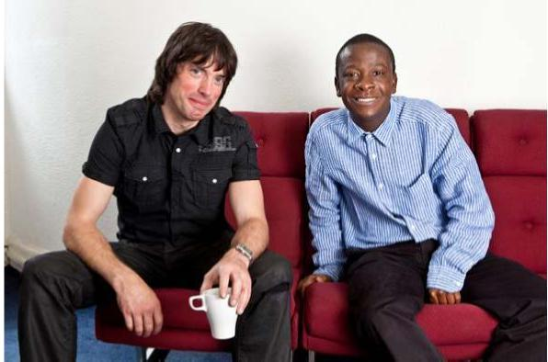

1995. Prospects opens its doors
Prospects is our employment and training service for people with Asperger syndrome looking for employment.
1997. Autism Helpline opens
The helpline is established started in order to answer the increasing number of calls and enquiries the organisation receives.
1997. Jane Asher becomes NAS President
Jane, having already been a Vice-President for some years, is made President of the NAS in recognition of all her hard work for people with autism.
1998. Daldorch House School opens
The school is in Ayrshire, Scotland. The school supports children and young people with autism aged five to 18. In addition, continuing educational opportunities and supported living arrangements are available for young people from 16-25 years as well as an outreach service for those aged five to 25.
2003. Countess of Wessex becomes NAS royal Patron
Her Royal Highness The Countess of Wessex takes over this role from Her Royal Highness The Princess Royal.
2005. NAS Northern Ireland office opens
The NAS Northern Ireland office opens in Belfast.
2009. Autism Act passed following NAS campaigning
The Autism Act 2009 becomes the first ever disability-specific law in England, after campaigning by the NAS.
2012. The NAS celebrates its 50th birthday
We’re proud to have been making a difference for 50 years.
2012. NAS Academies Trust is formed for the development of the first autism specific free schools. We now have free schools in Reading and Cheshire with another under development in Lambeth.
2013. First free school opens.
The National Autistic Society founds the NAS Academies Trust and opens its first free school, Thames Valley School.
2013. Ask autism is developed and launched.

Ask autism is a training service that has been uniquely developed and delivered by people on the autism spectrum and includes a range of online modules. It provides an 'insider' perspective of autism to give a unique understanding of how people on the autism spectrum would like to be understood and supported.
2014. The NAS Radlett Lodge School celebrates its 40th birthday Celebrations included a balloon release
2015. NAS Church Lawton School opens in East Cheshire.
This is our second free school and teaches children on the autism spectrum from the ages of 4-19
2015. The NAS holds its first ever World Autism Awareness Week
2015. The first NAS Cullum Centre opens at Salesian School in Surrey.
This is the first of four purpose-built specialist centres the National Autistic Society (NAS) and Surrey County Council are opening within mainstream secondary schools the area, thanks to generous financial support from the Cullum Family Trust
2015. The NAS Sybil Elgar School starts its 50th anniversary celebrations. This was the first autism-specific school in the UK, perhaps the world
2016. The National Autistic Society launch Too Much Information
This is the charity's biggest ever campaign. Too Much Information aims to increase public understanding of autism and launched with a video which was watched almost 60 million times

2017. The NAS Anderson School opens in Chigwell
This is a purpose designed and built independent school located on a large campus site, funded with the help of generous donations from the Anderson Foundation.

2019. A purpose designed and built Resource Centre in Belfast opened in the autumn
This represents a major development for the charity in Northern Ireland, providing much needed support for autistic people and their families.

2020. The NAS Vanguard Free School opens in Lambeth
After a lengthy gestation the Vanguard school opened in January this year and is the organisation’s third free school.

Looking forward
We are proud of what we have achieved but we know only too well that there is still much more to do. Our vision and mission still hold true and remain the focus for everything we do. However, as the economic, social and political landscape changes our strategy must reflect this. We have therefore produced a five year plan that focuses our work around four critical areas of activity — the 'pillars' of our strategy.
These are to;
- Deliver social change at a local level that will transform peoples understanding of and attitude towards people with autism and their families
- Become a partner for life for those people we support by providing them with the information and support they need at critical life stages from pre-diagnosis to entering older age
- To continue to strive for excellence in all of our services that we provide to people with autism helping them to lead the life they choose
- To support the knowledge and practice of professionals working in the field of autism with training, conferences and consultancy
Underpinning these pillars are three enablers
- We have to work to ensure that our autism expertise reflects the latest thinking and research
- In a tough financial environment much of what we do relies on charitable funding — our ambitions are large and so is the price tag. We therefore need to make sure we continue to grow our fundraising and commercial activities so that we can foot the bill and deliver the scale of impact we dream of
- All national organisations seeking to make a national and international impact require excellent support services — people behind the scenes that provide the people on the frontline with the support they need to do their job to the best of their ability. We have to make sure that all of these services behind the scenes are run as efficiently and effectively as possible.

Our structure

About the Board of Trustees
THE BOARD
The Board can have up to 16 trustees and meets, typically, four times a year. The October meeting generally extends over two days and combines a regular board meeting with a strategy day.
THE BOARD COMMITTEES STRUCTURE
The NAS Board of Trustees has five standing Committees, which are used to provide the detailed scrutiny of complex issues which cannot reasonably be undertaken at a main Board meeting, thereby facilitating the presentation to the main Board of a focused framework, analysis and recommendation from a trustees’ viewpoint.
These standing Committees are:
- Plans & Resources
- Services Quality & Development
- Education Quality & Development
- Audit & Risk
- Brand & Commercial Development
In addition, there is a Scotland Reference Group that provides advice and feedback on issues specifically related to Scotland.
In brief, the purposes of the standing Committees are as follows:
Plans & Resources
- Take the lead on developing and implementing mid to long-term operational plans, considering opportunities for growth (including by acquisition), identifying future trends and making recommendations to the Board on priorities for resource allocation;
- Take delegated responsibility on behalf of the Board for overseeing the financial framework of the charity and the effective use of its assets so as to ensure continued financial viability, reporting to the Board as appropriate;
- Take responsibility for the oversight of Human Resources management and performance;
- Take an overview of the charity’s property portfolio;
- Monitor corporate performance against agreed indicators and targets. Services Quality & Development
- Ensure high quality and consistent standards of practice are maintained throughout all contracted services with particular reference to the advancement of outcomes for individuals being supported;
- Monitor levels of service user satisfaction;
- Monitor compliance with legislative and regulatory requirements within contracted services, and compliance with the philosophy of choice, independence, inclusion and rights that underpins those regulations; and to

- Oversee service development to ensure contracted services evolve with the changing environment and Board expectations regarding outcomes.
Education Quality & Development
- Ensure high quality and consistent standards of practice are maintained throughout all NAS Group schools. These include independent schools, free schools and all other education based services for children that are regulated by Ofsted (England) or Education Scotland (Scotland) and delivered by the NAS through other channels. Also included are autism units based in mainstream schools and other non-regulated educational activities for children;
- Monitor the governance of schools owned, operated or managed by the NAS Group and ensure compliance with the law, regulations and the achievement of standards set by the Department for Education and by the regulators.
- Monitor the financial performance of the education services provided by the NAS Group to ensure their long term sustainability and timely investment for their planned future development;
- Monitor compliance with legislative and regulatory requirements with particular reference to the safeguarding of children;
- Monitor the outcomes of pupils and students against agreed targets relating to academic performance and social and behavioural norms.
Audit & Risk
- Oversee the external and internal audit processes and compliance with statutory and regulatory requirements, ensuring a framework for accountability;
- Examine and monitor the effectiveness of risk analysis and risk management; and to
- Take responsibility for monitoring the management of risk.
- Oversee the governance of the charity, ensuring it is effective and fit for purpose.
Brand & Commercial Development
- Support the Executive in increasing the generation of unrestricted income for the charity, in particular by developing new mechanisms through which funds might be raised;
- Oversee the development of the NAS brand and brand proposition, ensuring that all opportunities to exploit the value of the charity of the brand are maximised;
- Ensure maximum impact is obtained through the alignment of all campaigning activity (fundraising, media and political);
- Assist in the development of, and to consider and make recommendations to the Board upon, fully thought through business plans brought forward by the Executive;
- Oversee the development and expansion of social enterprises that address the needs of adults with autism and ensure opportunities for people with an ASC to participate in meaningful activity;
- Encourage and attract experienced entrepreneurs and business people to be co-opted onto the Committee;

- Encourage and support the growth and engagement of the NAS Membership and NAS Branches; and to
- Ensure compliance with all statutory and regulatory obligations associated with primary and non-primary purpose trading.
Scotland Reference Group
- Facilitate and support the mission of the NAS and the delivery of its strategy in Scotland;
- Provide advice to the Board on the best approaches to the implementation and development of services, taking account of Scottish practice, the Scotland constitutional context and other related factors;
- Support the NAS Scotland Senior Management Team in whatever ways are practicable;
All trustees are expected to sit on at least one Board committee and the aim is that none will sit on more than two.

Trustee Role
Trustees are responsible, in a non-executive capacity, for the overall governance of the NAS, developing its aims and goals, pursuant to its charitable objectives, within legal and regulatory requirements and guidelines. Trustees act as a body (but are accountable individually) to determine the overall strategic direction and to oversee the performance of the charity. Whilst Board and Committee work is inevitably a key focus, each trustee has a duty continuously to develop their knowledge and understanding of the charity and throughout their term of office to make a positive impact on its people and activities.
The roles of the trustees may be split into those concerning the work of the charity as a whole, and those covering the work of the Board, as follows.
Roles Concerning the Work of the Organisation
- To serve the objects and needs of the charity, and only those objects and needs, focusing on the prime aim of improving the lives of individuals affected by autism;
- To be familiar with all aspects of the charity’s work and the legal and practice contexts and constraints in which the charity operates, by visiting services and undertaking learning and development activities by way of personal initiative and through discussion with the Chair of Trustees;
- To shape and periodically redefine the Vision, Mission and Values of the charity;
- To form the charity’s strategy, set corporate policy and agree goals and targets;
- To establish broad policies, including matters to be reserved for Board decision, ensuring they are in keeping with the charity’s objects;
- To allocate resources between the various and diverse activities of the charity and to balance different stakeholders’ interests insofar as this is in the best interests of the charity;
- To appoint and support the Chief Executive, establishing a constructive working relationship;
- To provide clear strategic direction to the Chief Executive and executive management team, agreeing performance measures for the organisation as a whole, and monitoring performance against those measures;
- To ensure regulatory compliance by taking appropriate and necessary steps to:
- ensure that the charity pursues legitimate objectives and adheres to the principles and objects laid down in its constitution which should be periodically reviewed in order to ensure it remains fit for purpose as the charity evolves;
- ensure that the charity applies its resources effectively and solely pursuant to its objects;
- ensure the charity’s financial stability;

- ensure the assets of the charity are safeguarded;
- ensure the proper investment of the charity’s reserve fund(s).
- To safeguard the good name and ethos of the charity. Roles Concerning the Work of the Board
- To comply at all times with the Board Rules and the Trustees’ Code of Conduct, particularly at meetings of the NAS Board, when otherwise exercising the functions of a Trustee and when serving on any Committee.
- To attend all Board, allocated Committee(s) and General Meetings of Members whenever reasonably possible to do so, explaining any absences to the Chair of Trustees/Committee as relevant;
- To use any specific skills, knowledge or experience they bring to the table to help the Board reach sound decisions – this will involve scrutinising Board papers, leading or contributing to discussion, focusing on the relevant issues, and providing advice and guidance to the Chair and Chief Executive on areas in which the individual trustee has special expertise;
- To raise an issue in open meeting or, if concerned that the Board’s intended direction is not in the best interests of the charity, with the Chair outside it;
- To accept collective responsibility for decisions of the Board and to uphold those decisions;
- To maintain Board confidentiality;
- To facilitate the recruitment and induction of new trustees;
- To contribute to the monitoring of the Board’s performance and that of its Committees, including offering and receiving performance appraisal.
Trusteeship is a serious responsibility, particularly in a charity of the stature and complexity of the NAS, and requires an active role in its governance. Reading Board and Board Committee papers, attending meetings, continuous personal development and remaining informed about the charity's activities and the environment in which it operates, require time and self-sacrifice.
Please note that trustees are unpaid volunteers although out of pocket expenses are reimbursed.
Person specification
All Committee members need certain qualities, such as integrity, passion and commitment, but not every member needs the full range of experience required by the Board as a whole. Some members will need to have experience of the nature of autism, or of care practice, whilst others can offer experience of business management, schools and education, care provision or other relevant professional skills.
The current specific need is for two individuals, one with senior level experience of financial management and strategic planning and the other with experience of schools and education, including experience of the education of children with special educational needs.
The finance specialist will most probably have current or former experience as a Finance Director in an organisation of comparable size and complexity. He or she will chair the board’s plans and resources committee and take a leading role in ensuring the continuing financial health of the charity. The committee typically meets four to six times a year.
The second person will have current or recent experience of the operation, management, governance and regulation of schools, preferably including the education of children with special educational needs. They will chair the local governance body of one of the NAS schools located in London or the home counties* and will also sit on the board’s education, quality and development committee. This arrangement ensures a direct link between the board and the school. Both the local governance bodies and the committee typically meet three times a year.
*The NAS has schools in Berkshire (Reading), Hertfordshire (Radlett), London (Southall and Lambeth), Essex (Chigwell) and Kent (Meopham).
More generally:
Each trustee must have:
- a commitment to the charity and to equality of opportunity within a diverse environment;
- a willingness to devote the necessary time and effort;
- an understanding and acceptance of the responsibilities of trusteeship;
- an ability to work at a strategic level, think creatively and criticise constructively;
- good, independent judgment with a willingness to speak their mind, but with a willingness to be persuaded and/or accept and uphold the views of the majority;
- an ability to add value by being creative in framing the real issues and in bringing a fresh, discerning and authoritative perspective to addressing those issues;
- an ability to be objective and to challenge assumptions;
- an ability to work effectively as a member of a team, and to respect confidences;
- In short: a commitment to Nolan’s seven principles of public life – selflessness, integrity, objectivity, accountability, openness, honesty and leadership.
The Board as a whole needs skills and experience in the following areas:
- living with autism at all ages (either having a diagnosis or being a parent/carer);
- organisational management and strategic planning in commercial, statutory and non-profit organisations;
- business and financial management;
- education and care, including risk management, safeguarding and quality management;
- marketing and campaigning;
- public affairs and public relations;
- fundraising and income generation;
- human resource and legal matters;
- commercial development and trading.
The ideal Board would also have:
- a satisfactory age, gender and diversity mix;
- a mix of parents who have a child and adult family member(s) with autism;
- a mix of parents who have a family member with low and high functioning or cognitive capacity;
- autistic trustees across the spectrum (linked to appropriate benefit/outcomes and participation mechanisms).

