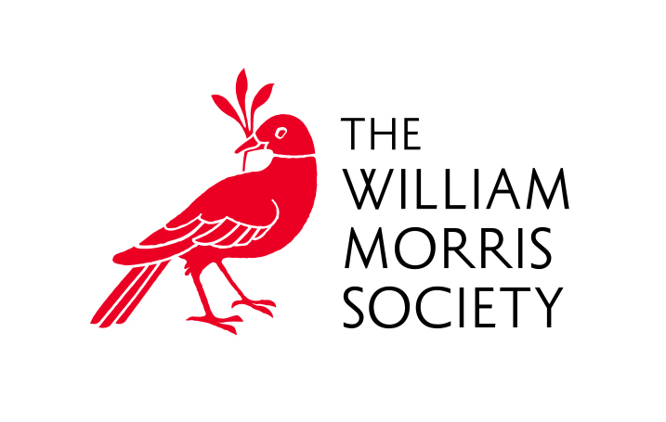
WMS Trustee role description
Overall purpose
The purpose of a Trustee is to individually and collectively take legal responsibility and accountability for the overall governance and strategic direction of the Society, developing aims, objectives and goals in accordance with the governing documents. The William Morris Society is a Charitable Incorporated Organization (CIO) under charity law. Trustees are obliged to sign and abide by, the Trustee Code of Conduct on appointment.
Key responsibilities
The key responsibilities of trustees are:
1. Legal
- To ensure that the charity complies with its governing documents, charity and company law and any other relevant legislation or regulations.
- To ensure that the charity pursues its objects as defined it its governing documents
- To ensure that the charity uses its resources exclusively in pursuance of its objects. The charity must not spend money on activities which are not included in its own objects no matter how worthwhile or charitable those activities may be
- To act in the best interests of the charity, its beneficiaries and future beneficiaries at all times
2. Strategic
- To contribute actively to the Society Trustee Board, in giving clear strategic direction to the charity, setting overall policy defining goals and objectives, and evaluating performance against agreed targets. To keep under review the long term development of the charity in light of the political, social and economic environment in which it operates.
- To safeguard, promote and represent the good name and values of the Society
3. Financial
- To ensure the financial stability of the Society
- To approve the annual budget
- To ensure the proper management of the property of the charity and to ensure the proper investment of the charity’s funds
4. Other
- To assist in the appointment of senior staff
- To ensure the effective and efficient administration of the charity
- To attend the Society’s AGM
- To ensure that appropriate advice is taken from professional advisers on matters where there may be material risk to the charity, where Trustees may be in breach of their duties, or on any other matters considered by Trustees to be appropriate for the effective operation of the charity
- To maintain the confidentiality of all sensitive/confidential information received in the course of a Trustees responsibilities
Trustees must be members of The William Morris Society.

