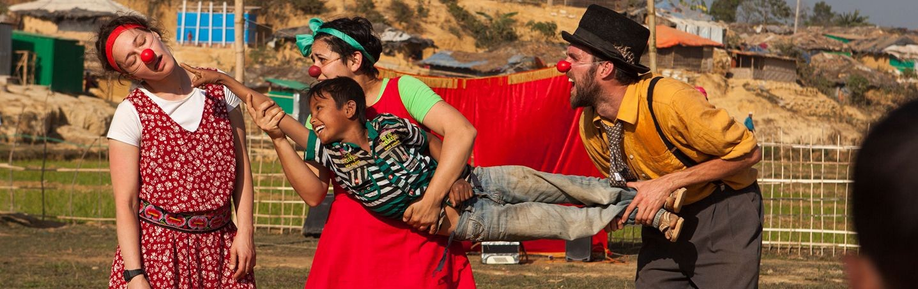

Performance for Rohingya children, Bangladesh, Jan 2018

“Maybe for you this day is a small thing. For us, this is very, very big.
You have made my children very, very happy.”
Father, Tompa Tansit Zone, Hungary

Clowns Without Borders

ROLE: Board Trustee, Treasurer

SALARY: N/A – Voluntary Role

BASE: Home working, Zoom

ACCOUNTBALE TO: Chair of Trustees

History

Clowns Without Borders UK was established in 2014 and we have delivered over 30 projects in 13 countries
sharing laughter with over 55,000 children. With a team of 18 professional clowns we share joyful
performances and workshops with children in Humanitarian Disasters. We are also members of Clowns Without Borders International (CWBI), an umbrella organisations formed of 15 International Chapters with headquarters in Barcelona. CWBI is also a Consultative Member of UNESCO in recognition of our commitment too peace, tolerance and cultural diversity.

Mission

To alleviate the suffering of children by sharing joy and play when they need it most.

We delivery this mission through:
- Non-verbal, highly visual performance and workshop for children
- Capacity-building of staff and volunteers to use play to support the wellbeing of children
- Creating strategic partnership with other NGO’s to increase our reach and capacity and to advocate for the benefits of CWB’s approach

Governance

The Board is the ultimate governance body for the charity, serving as stewards of its resources, and ultimately responsible for our strategy, operations and financial management. Our board ensures we comply with our governing document and charity law and pursue our objectives. They are responsible for providing supporting, guidance and decisions to the CWB team, ensuring the effective and efficient administration of the organisation.

Trustees are elected for a 2-year term but with the opportunity to be re-elected.

The clowns in Katmandu after Nepalese earthquake, 2015

Trustee Responsibilities

Strategy and Governance
- To contribute actively to the Board of Trustees’ role in giving firm strategic direction to the charity, setting overall policy, defining goals and setting targets and evaluating performance against agreed targets
- Ensuring high standards of governance and risk management
- Ensuring the organisation is accountable and transparent in its activities
- Ensuring compliance with relevant charitable and company legislation
- Safeguarding the interests of Clowns Without Borders’s beneficiaries

Financial
- Ensuring sound financial oversight including review and approval of the annual budget
- Oversight of high standards of financial management

Advocacy
- Act as an ambassador for Clowns Without Borders

Specific Expertise
- Liaise with the Executive Director to ensure that appropriate accounting procedures and controls are in place and followed
- Oversee and present budgets, accounts, financial statements and financial reports to the Board
- Ensure that the financial resources of the charity meet its present and future needs and are within the charities objectives
- Support the Executive Director to develop and implement appropriate financial and reserves policies

Person Specification

- Passionate about the arts, culture and it’s ability to create positive impact
- Passionate in Children’s Rights
- Embodying the values of CWB and endeavoring to maintain a spirit of joy, peace, compassion and loving kindness in the way we work together on the Board
- Enthusiastic about our mission and able to support this through the sharing of ideas, professional expertise and networks

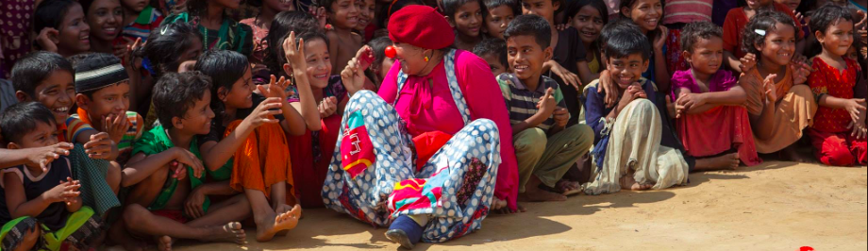

Time Commitment

Trustees are asked to give around four to six days per year to Clowns Without Borders UK . We have three Board Meetings per year usually over Zoom as our Trustees are based around the world. We aim to have one face-to-face meeting per year, usually in London.
We ask all of our Trustees commit to preparing for and attending Board meetings and additionally supporting and working with the organisation where their skills and expertise can best be used . We recognise that Trustees will have to balance their commitment to Clowns Without Borders UK and work commitments and aim to be as flexible as we can.
Remuneration

The position of Trustee is unpaid. However, all reasonable out-of-pocket expenses incurred will be reimbursed in line with our Expenses Policy.

Application and Interviews
Please submit a cover letter outlining why you would like to be our Treasurer and CV to:
sam@clownswithoutborders.org.uk

The deadline for applications is Monday 9th November 2020
Interviews will be held w/c 16th November.

Please Contact

If you can have questions or would like more information please do not hesitate to contact
sam@clownswithoutborders.og.uk

