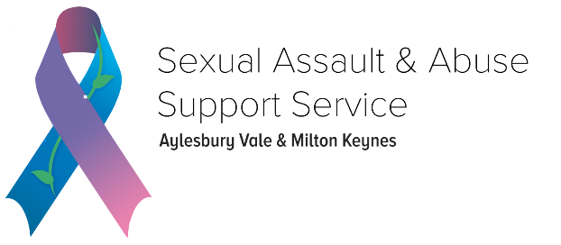

Trustee Role Description - Treasurer
Exciting time of growth and development as our small but ambitious charity continues to develop its service offer for those affected by sexual violence and abuse. We are seeking a skilled individual to join our dedicated team of volunteers although we do not require someone with previous trustee experience as we are happy to provide training.
Who are we?
We are a Charitable Incorporated Organisation serving those in Aylesbury Vale and Milton Keynes who have been affected by sexual assault and abuse recently or in the past. We support individuals to live fulfilling lives regardless of gender, race and sexuality. We provide face to face counselling, telephone and email support, information and guidance sessions, and an ISVA service (practical and emotional support). We are members of Rape Crisis England and Wales, Survivors Trust and the British Association for Counselling and Psychotherapy.
The Role
We are recruiting for a trustee with accounting and finance experience to serve as treasurer. The role will require 6-8 hours per month including a monthly meeting with the CEO and a trustee meeting on the third Thursday of every other month which is currently online. Our volunteers and trustees have 'real lives’ so flexibility is accounted for. The trustees also run action groups in between the main trustee meetings to develop relevant themes when needed.
Key responsibilities:
You will be working closely with the CEO to:
- oversee the organisation's continued income growth and ensuring compliance with Charity Commission requirements
- agree and monitor a sustainable annual budget
- work with CEO and designated accountant to oversee the preparation and submission of relevant Charity Commission reports
What skills are we looking for?
- Our ideal trustee will have accounting experience, preferably using online tools (e.g. Xero)
- experience setting and monitoring annual budgets and will be able to advise on financial policies and procedures.
What difference will you make?
By working with the current board to advise and oversee financial growth, the organisation is able to ensure its services are sustainable, and that the growing demand for support from those who have experienced sexual abuse is met. Police statistics are showing an increase of sexual offences recorded, and many survivors of abuse endure psychological trauma for years before seeking support. The treasurer will play a key role, working alongside the CEO, to ensure the organisation is financially stable and able to continue to offer support to survivors, and can grow in a sustainable way to offer a more diverse range of services so no one is left without help.
What’s in it for you?
Joining our organisation at this time provides a significant opportunity to affect real change in the development of services, which will have real impact on those accessing support for the profound and often devastating negative impacts of sexual violence. If you want to be involved in change, growth and improvement directly, this is a brilliant opportunity. We're not looking for just another board member but another member of the team to join our mission to enable survivors to live fulfilling lives.
Think you might be a good fit? We’d love to meet you!
Please contact our Chair, Helen Cavill via helen@avmksaass.org.uk or 07712 439146

