Trustee Recruitment Information
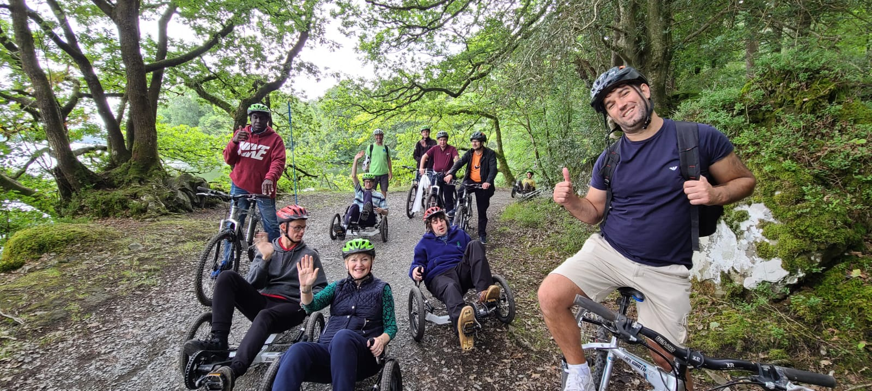
Contents
- Welcome from the Chair of Trustees
- Frieda Scott Charitable Trust – Who we are & what we do
- Role Description & person specification
- Equality, Diversity & Inclusion
- How to apply
Welcome from the Chair of Trustees
Many thanks for your interest in joining the Frieda Scott (FSCT) in the role of Trustee. Our Trustees
play a significant part in helping to support some of the many charitable organisations which underpin
and enhance community life in our area, and help us to make sure that our funds are distributed to the
best effect. You would be joining a friendly and committed team of Trustees, who look forward to
meeting and supporting some new Board members.

Here at FSCT we are keen advocates for and supporters of the rich breadth of community activity across
our geographical beneficiary area. For almost 50 years the Trust has prioritised support for those who
benefit most from this provision and we are proud to be part of the sector locally.

We achieve this through the distribution of over £300k a year to those organisations working in the old county of Westmorland and the South Lakeland District Council area, to support the most vulnerable in these communities and promote a high quality of life for all, with particular priorities over the past five years focussing on supporting positive mental wellbeing, reducing rural isolation and inclusion for those with disabilities. The Trust also has a very active small grants committee, which has supported over 75 village halls over the past 20 years.

Grant awards are typically made for a year at a time, but multi year awards can be and are made, particularly to organisations we have known over a period of time and who meet pressing needs in their communities. The majority of main grants awarded are a contribution to revenue costs including, but not limited to salaries for staff, whilst the bulk of small grants are contributions to larger capital costs, such as village halls and playgrounds.

It is a difficult time for the sector, which brings into sharp focus the need to work effectively and ensure everything we do as a grant funder matters.

We have a small staff team based in Kendal and a Board currently made up of eight Trustees who meet to consider all eligible applications three times a year. Trustees are also responsible for the Governance and oversight of all the Trust’s activities. This work is managed through a series of sub-committees. All Trustees serve on one or more sub-committees, depending on their expertise and areas of interest.

We are looking for two new Trustees to join our highly engaged Board and are particularly keen to appoint individuals with a connection to our beneficial area who have experience of the voluntary sector.

We hope the following pages will inspire and encourage you to consider joining us in these endeavours.

Samantha Scott, Chair of Trustees

Who we are & what we do

Frieda Scott Charitable Trust (FSCT) was originally established in 1962 as the Second Matson Ground Charitable Trust by Francis, Frieda and Peter Scott. The name was changed in 1974 after Frieda Scott’s death in 1973. The Trust was endowed by Francis and Frieda Scott and subsequently received further assets from their daughter Dr Joan Trevelyan, and the Francis C Scott Trust.
The Trust Deed awards wide powers to Trustees both to invest the assets and to distribute for charitable purposes. The Trust has always retained an interest in the Westmorland and South Lakes area, where Frieda Scott was actively engaged in and supportive of various aspects of community life. Frieda Scott was particularly aware of and keen to support those affected by the principle challenges of her time, and the current Trustees remain true to this ethos, prioritising groups who are adversely affected and those who benefit most from community activity.

FSCT funds both charitable organisations and social enterprises where their objectives are charitable in nature and not for private profit, are clearly in the community interest and reflect our own objectives and approach.

We distribute approximately £330k in grants each year, which range in size between £3,500 and £20,000. Trustees consider grant applications three times a year, with applications being received, reviewed and assessed by the team on an on-going basis. A small grants committee makes smaller awards of up to £3,500.

For further details of how we achieve our objective, our key priorities, and additional programmes, please visit the website at www.friedascott.org.uk

Our investments are managed by professional investment managers with a view to balance the needs of current and future beneficiaries and are overseen by the Trust’s Investment Committee.

Our small staff team also distributes funds for two other Charitable Trusts which were founded by other members of the Scott family. The trusts share the same financial heritage based on the success of the Provincial Insurance Co. and the enduring generosity of the Scott family, but they operate today with independent boards of trustees and distinct strategies.

ROLE DESCRIPTION

Title: Trustee

Responsible to: Chair of Trustees

Work schedule: Three half day Trustee meetings annually
Up to three half day sub-committee meetings annually
Trustees are invited and encouraged to join applicant and community visits which happen throughout the year. All new grant applicants are visited by Trustees and in the interest of sharing the work load, we request that all applicants consider their availability for making one or two visits during the year.
The above is indicative, Trustees review from time to time the work schedule and meetings timetable of the Trust, so this may change at Trustees discretion.
Salary & benefits: This is a voluntary role. Out of pocket expenses will be met

Purpose and main functions of role
The Trust’s governing document is the Trust Deed dated 15th September 1962. The Deed gives Trustees considerable discretion over the investment of Trust assets and the distribution of income and capital.
Trustees have legal, fiduciary and moral duties to act in the best interests of the Trust in the course of their duties.
As a Trustee you will be collectively responsible with the rest of the Board for the Governance and oversight of all the Trust’s activities including grant decision making, investment management and financial oversight.
Our Trustees are highly engaged and committed and new Trustees will be expected and supported to make an active contribution to discussions, decision making and holding the executive team to account, providing in turn both challenge and support.

KEY ROLE & RESPONSIBILITIES

- Contribute to the strategic direction of the Trust
- Maintain the Trust’s charitable objectives and priorities at the forefront of decision making
- Review and approve key policies and resolutions, including but not limited to Trustees Annual Report and Accounts, risk register, budget.
- Monitor implementation of policies and processes
- Review and agree the Trust’s investment policy annually
- Ensure the appropriate management and administration of the Trust is in place
- Consider and collectively decide on the awarding of grant applications
- Prepare for, attend and actively participate in Trustee and sub-committee meetings
- Act in the best interests of the charity and to the best of your ability
- Comply with statutory regulations and legal requirements under relevant Trust and Charity Law
- Openly declare conflicts of interest and comply with the Trust’s policies

Person Specification
We have a strong board with significant Governance, leadership, finance and strategic skills. We are looking for Trustees who will enhance and complement these, whilst contributing to our diversity of thought, background, and experience. Some additional characteristics we are looking for are:
- A commitment to our charitable objectives, priorities and geographical beneficiary area
- An inclusive, open mindset which values and accommodates different perspectives
- Ability to collaborate and work within a group
- Integrity
Individuals with a working knowledge of or experience in human resource management are particularly encouraged to apply.

Equality, Diversity and Inclusion
The Trust is committed to providing equity of opportunities and welcomes applications from people with different requirements and from groups typically under represented at Board level and who are part of our diverse communities.

Location
Trustee meetings are typically held at our office base in Kendal, and sometimes elsewhere within our beneficiary area of South Lakeland and the old County of Westmorland. As far as possible, Trustees are expected to physically attend full Board meetings which happen three times a year in mid-March, mid-July and mid-November.
Sub committee meetings are also held in Kendal, but can be attended virtually as necessary.
Applicant and community visits happen physically where possible and virtually by agreement.
Periodically the Trusts holds additional events to which Trustees are invited to attend.

How to apply and appointment process
If you have any questions about the role or the application process, please email helen@fcsct.org.uk or telephone
015395 742608.

Please send your CV and a covering letter outlining why you are interested in the role and demonstrating what you would bring to it. Please use the qualities listed above as a guide and ensure your CV includes your full name, address and contact details.

Candidates will be shortlisted based on their covering letter and CV.

Deadline for receipt of applications
This vacancy closes at 10am on June 6th. Any submissions received after this time will not be considered.

Your letter & CV should be returned by one of the following methods:

By email: helen@fcsct.org.uk

By post: Helen Carter, Scott Trusts, Stricklandgate House, 92 Stricklandgate, Kendal, LA9 4PU

Acknowledgement of receipt
Applications will be acknowledged by email within a working day of receipt.

Interviews
Interviews will be held following a shortlisting process. Candidates will be contacted separately to agree convenient times and dates. Please advise us of any reasonable adjustments you may require to attend the interview when submitting your CV and cover letter.

